Project Design Phase - II

Data Flow Diagram & User Stories

|  |  |
| --- | --- |
| Date | 12 October 2022 |
| Team ID | PNT2022TMID24924 |
| Project Name | SMARTFARMER – IOT ENABLED SMART FARMING APPLICATION |
| Maximum Marks | 4 Marks |

Data Flow Diagrams:

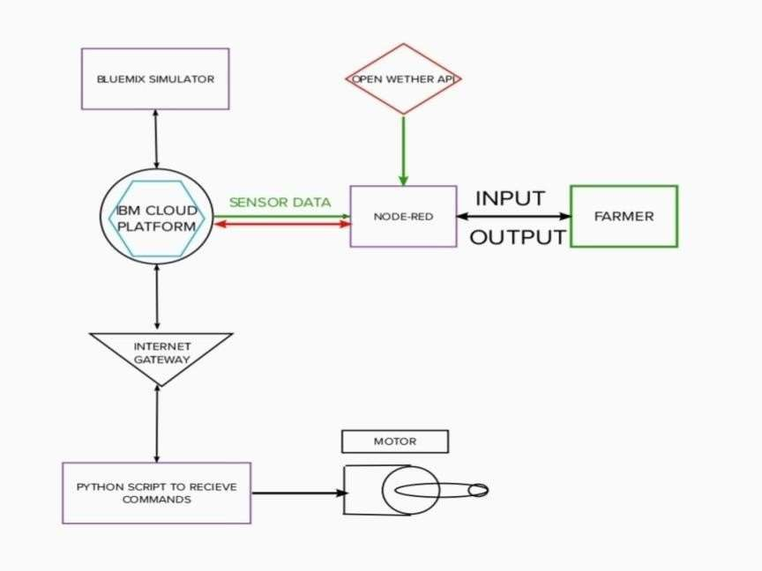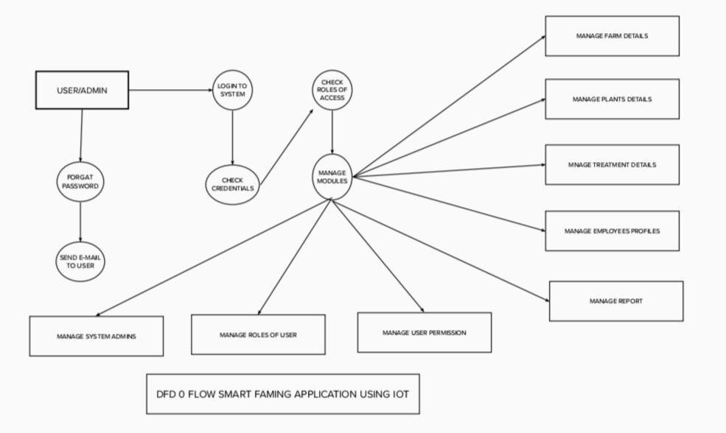

|  |  |  |  |  |  |  |
| --- | --- | --- | --- | --- | --- | --- |
| User Type | Functional  Requirement (Epic) | User  Story  Number | User Story / Task | Acceptance criteria | Priority | Release |
| Customer (Mobile user) | Registration | USN-1 | As a user, I can register for the application by entering my email, password, and confirming my password. | I can access my account / dashboard | High | Sprint-1 |
|  |  | USN-2 | As a user, I will receive confirmation email once I have registered for the application | I can receive confirmation email & click confirm | High | Sprint-1 |
|  |  | USN-3 | As a user, I can register for the application through Facebook | I can register & access the dashboard with Facebook  Login | Low | Sprint-2 |
|  |  | USN-4 | As a user, I can register for the application through Gmail |  | Medium | Sprint-1 |
|  | Login | USN-5 | As a user, I can log into the application by entering email & password |  | High | Sprint-1 |
|  | Dashboard |  |  |  |  |  |
| Customer (Web user) |  |  |  |  |  |  |
| Customer Care  Executive |  |  |  |  |  |  |
| Administrator |  |  |  |  |  |  |
|  |  |  |  |  |  |  |
|  |  |  |  |  |  |  |
|  |  |  |  |  |  |  |

User Stories